Report: Laboratory work 6

**Analysis of accuracy decrease of filtration in conditions of correlated biased state and measurement noise**

Team #1: Viktor Liviniuk, Alina Liviniuk

The objective of this laboratory work is to analyze the sensitivity of estimation results obtained by a Kalman filter that doesn’t take into account bias of state and measurement noise.

**Divergence of Kalman filter when bias of state noise (acceleration) is neglected in assimilation algorithm. Development of optimal Kalman filter that takes into account bias of state noise (acceleration).**

A trajectory 𝑋𝑖 of an object motion disturbed by normally distributed BIASED random acceleration was generated. Measurements of the trajectory were also generated.

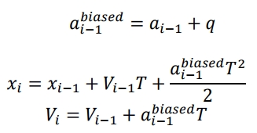

Also, estimates of state vector 𝑋 = | 𝑥 𝑉 | by Kalman filter in assumption of unbiased acceleration (𝑞 = 0) where made:

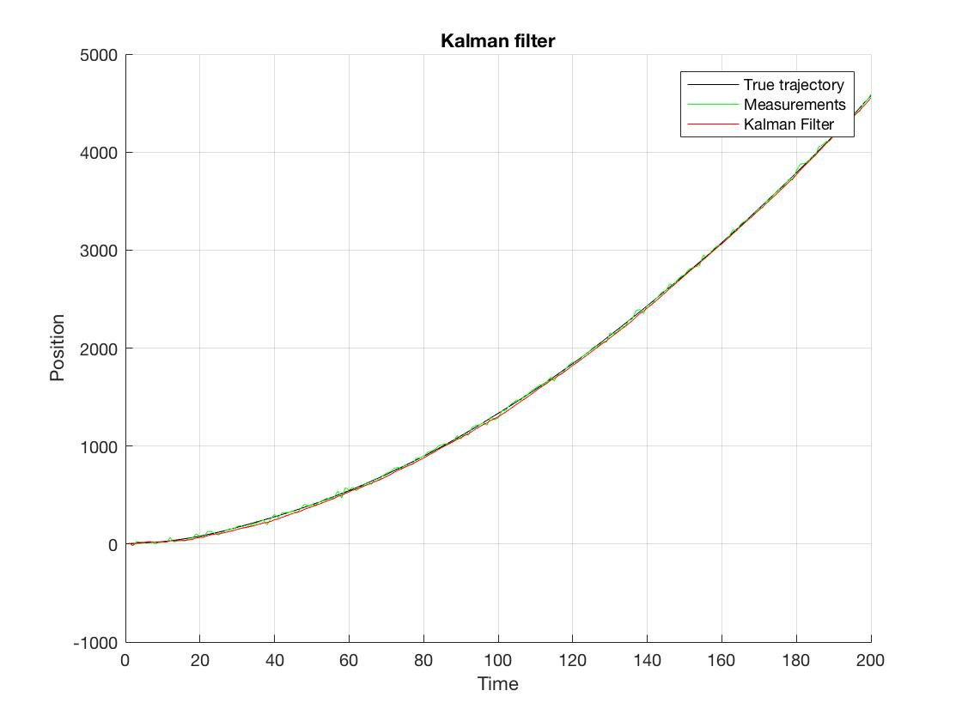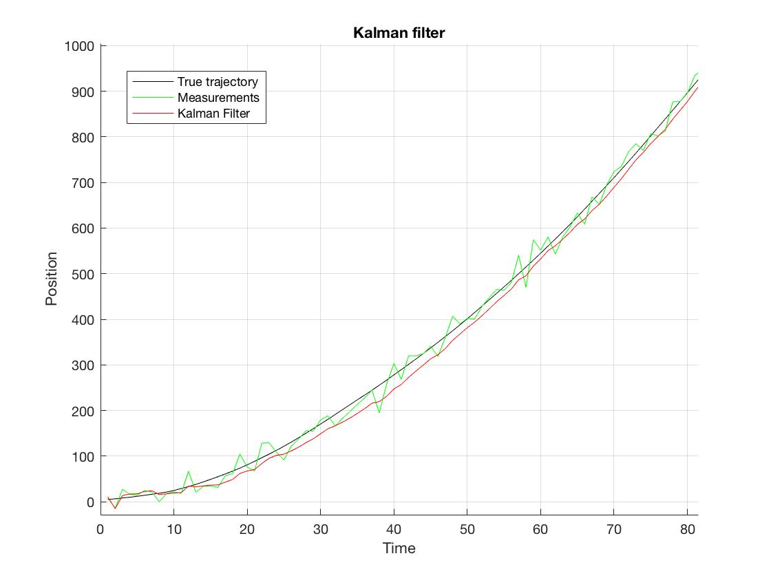

After 500 runs of filter and dynamics of mean-squared error of estimation over observation interval was estimated:

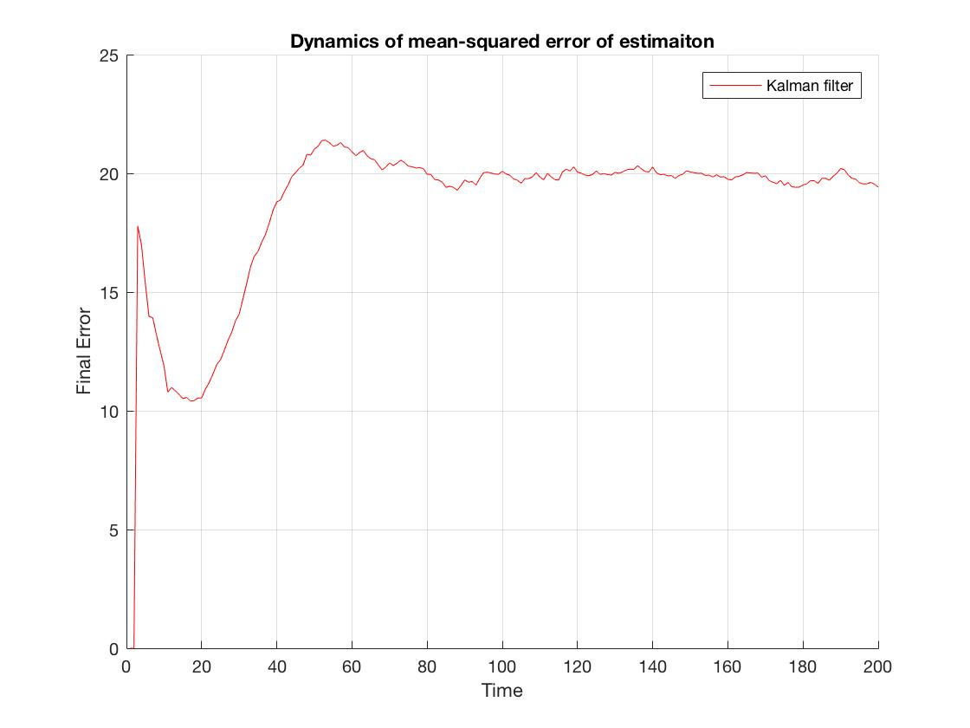

The true error is high – it saturates at about 20.

To compare true estimation error with errors of estimation, provided by Kalman filter algorithm, the following plot was made:

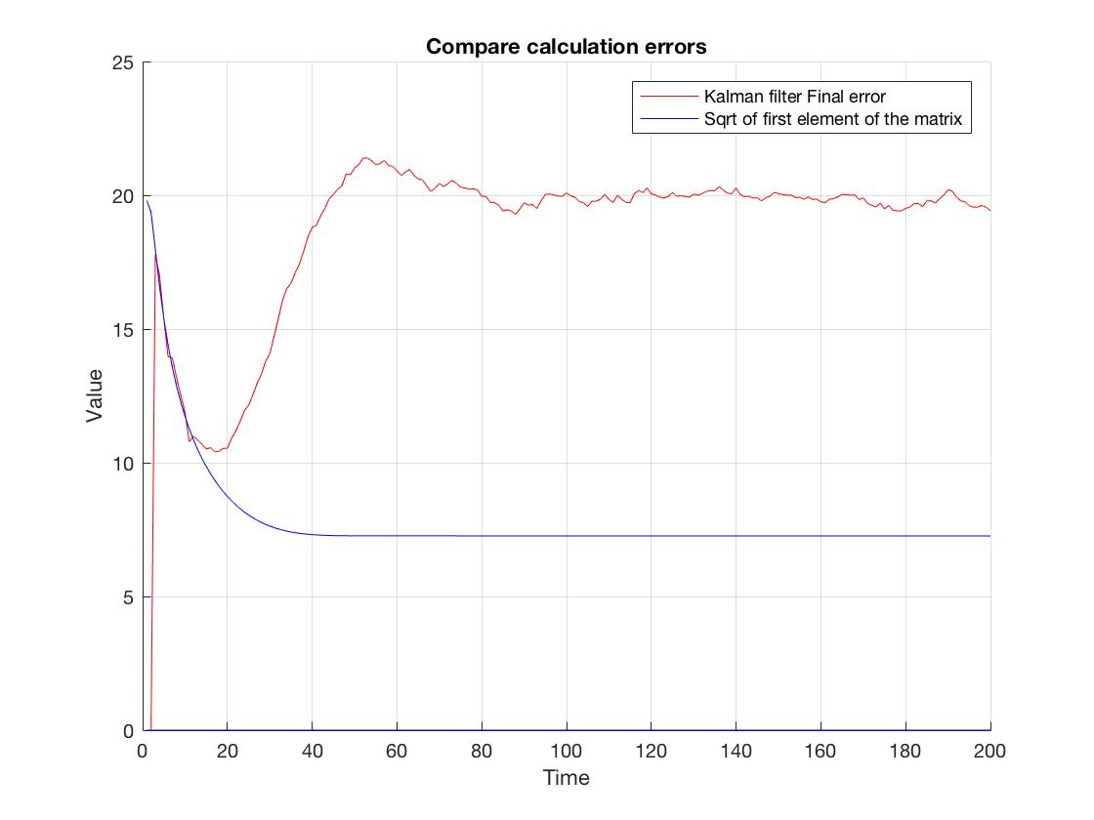

The true error corresponds to calculation errors of estimation only at first steps, then increases and becomes 3 times greater. The filter is non-optimal.

Kalman filter that takes into account bias of acceleration was constructed:

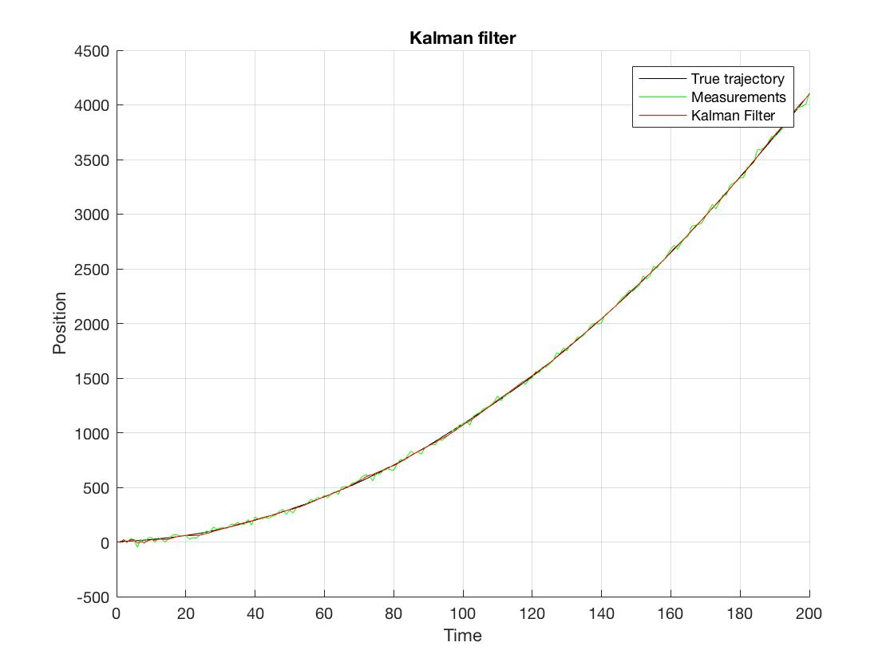

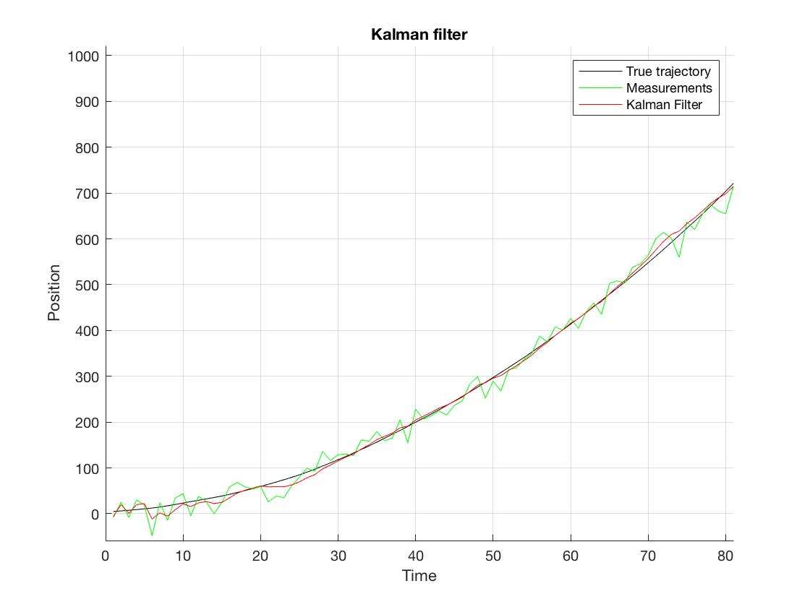

In optimal conditions, true error corresponds to calculation errors of estimation:

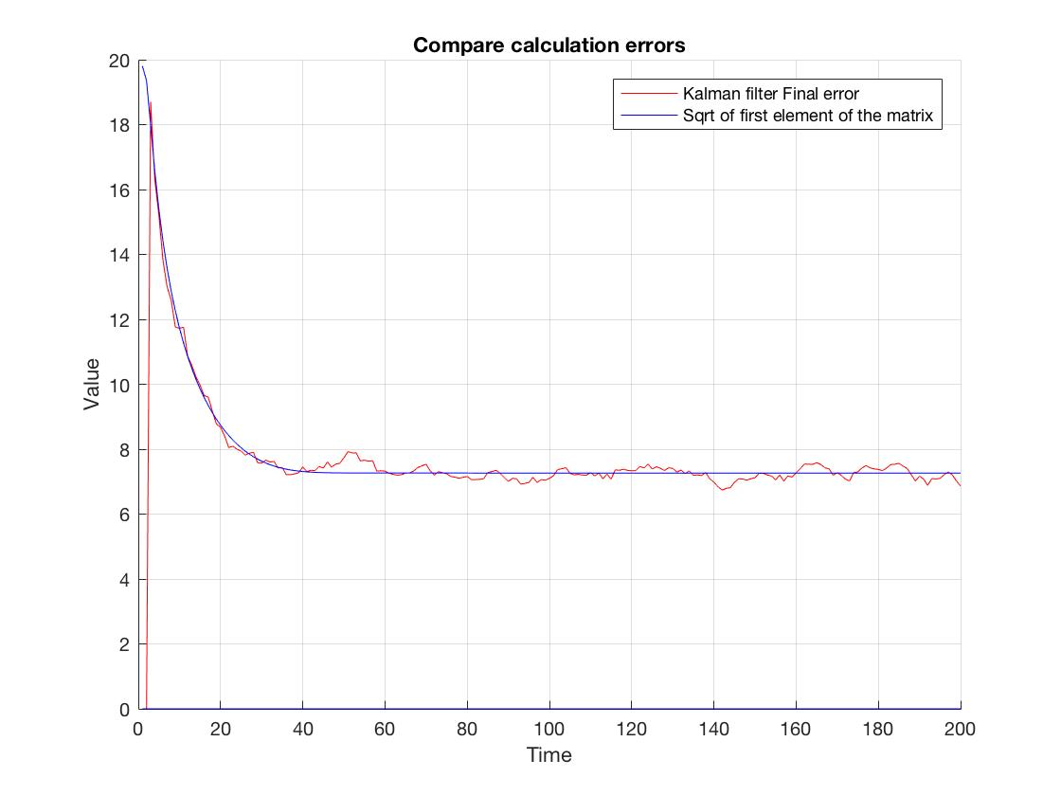

**Conclusion**

Kalman filter should be used in optimal conditions. When Kalman filter that doesn’t take into account bias of state and measurement noise, error of estimation greatly increases, because of the method’s sensitivity.